26th June 2017

**Michelisz strikes back in WTCC Portugal**

Hungarian Norbert Michelisz was ecstatic with his FIA WTCC main race victory at the weekend in Portugal’s Vila Real street circuit. Following a good qualifying session, Michelisz had managed to secure the pole position for the race and this time there was no stopping him in securing his first victory of the season and valuable points in the Championship challenge.

The FIA World Touring Car Championship with Japanese premium tyre manufacturer YOKOHAMA as exclusive tyre supplier did not disappoint in Portugal. Thousands of passionate Portuguese fans, cheered on their home hero Tiago Monteiro throughout the weekend. The energy of the crowds quickly boosted Monteiro’s confidence as he eventually hit a double podium to put him and the factory Honda team in front of the Championship, to the detriment of Nicky Catsburg.

Monteiro came from 7th to 2nd in the Opening Race before taking a meritorious 3rd in the Main Race to reclaim the title initiative over new second-placed contender Thed Björk, the Polestar Cyan Racing driver also taking two podiums in his Volvo S60. The race of Portugal had also excited fans with a new alternative route to enable drivers overtake on challenging street tracks – the joker lap as it has been called, and it did not disappoint.

After the race, Monteiro spoke to the media. “Two podiums on a track where it’s hard to overtake wouldn't have been possible without the ‘joker’ lap. It was a good success and congratulations to the organisers of the idea. To have put this altogether in such a short amount of time was not easy but, in the end, the result paid off and it could be interesting for the future.”

Bennani was also on fighting form for Sébastien Loeb Racing with his second victory of 2017 in the Opening Race. He had started fourth on the reverse grid, but was in the lead by the end of lap one and controlled the 11-lap race all the way to the chequered flag. Bennani is now in 5th overall position within the Championship.

Tom Chilton was twice in the top six but was unable to resist fellow Citroën privateer Rob Huff, who fought back from last to fifth in the Main Race with a storming drive for ALL-INKL.COM Münnich Motorsport. Nicky Catsburg who led the standings heading to Portugal for Polestar Cyan Racing has now slipped to third, 10 points behind Monteiro after finishing fourth and fifth in the two races.

NEXT FIA WTCC Race of Argentina, Termas de Río Hondo, 14-16 July

Current Driver Championship Standings:

1 Tiago Monteiro 164

2 Thed Bjork 160

3 Nicky Catsburg 154

4 Norbert Michelisz 137

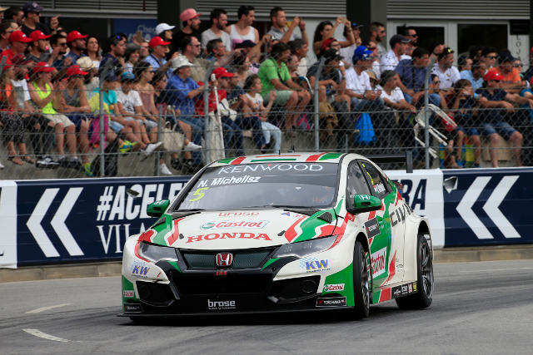

*Crowds cheer leading car*

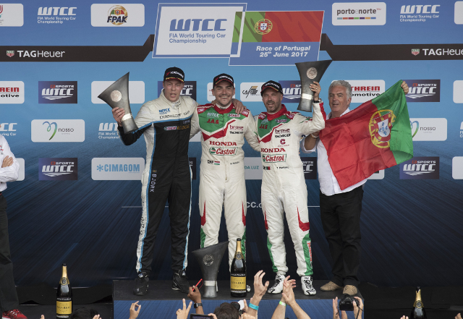

*Michelisz celebrates podium in main race*

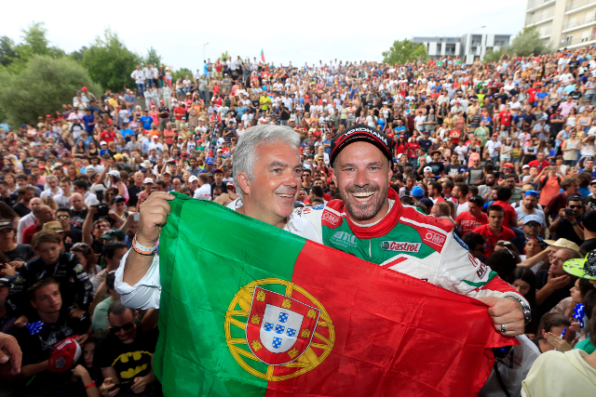

*Great Home support for Monteiro*

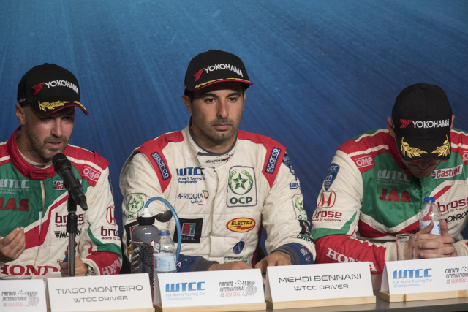

*Bennani at the press conference*